CARD 3
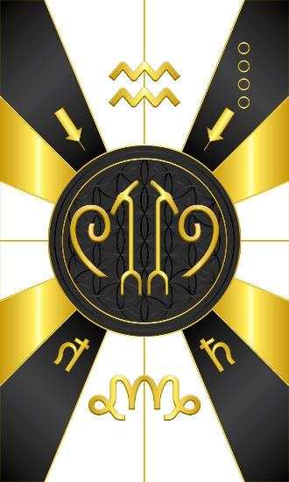
Card 3 represents the energy of Olokun and Sekert. Olokun is revered as the ruler of all bodies of water and for the authority over other water deities. Olokun is greatly praised for their ability to give great wealth, health, and prosperity to their followers. Communities in both West Africa and the African diaspora view Olokun variously as female, male, or androgynous.
The guardian of the deepest depths of the sea, Olokun is the owner of the oceans and all the riches that they possess. The deep sea is her kingdom, and she resides there happily.

Olokun is deeply tied to the Orisha Yemaya, and the two are often mixed up. Some people believe that the two are husband and wife, while others say that they are brother and sister. Yemaya looks after the shallower parts of the seas. She is the Orisha of motherhood, and the waves and tides fall under her realm. While the two share the same element of nature, their temperaments are extremely different.
The name Olokun is derived from the word “olo” meaning "owner", and "okun" meaning "ocean". He/she possesses unmatchable wisdom, governs over dreams, wealth, prosperity, meditation, and healing. Olokun is respected as an authority over all other water deities.

Olokun is an Orisha full of deep mysteries. She is often associated with dark or left-hand path magic. The reason for this is that no light ever hits the bottom of the ocean where Olokun lives. She embodies the necessary darkness that is within us all; the drive that every living thing possesses to survive. In the same way that Yemaya is the creative force of life, Olokun is the equally necessary destructive force of life

Card 3 has the Uas Sceptre and the hieroglyphic determinative for the 'U' sound, which is used in words that have to do with creating, like Heka'u", which is Words of power. The Uas scepter symbolizes the happiness and well being resulting from due attention to the flail and crook. Keeping them in balance leads to well being and success. The flail symbolizes the harshness with which we must deal with ourselves for violating our pledges of discipline, while the crook corresponds to the gentile meditative and ritualistic methods to the same end. It is pictorally a spiral. Then I have the Shekhem symbol for Power. The rest includes the constellations for Capricorn (Earth) and Aquarius (Air) and the astrological glyph for Saturn.

Comments by Baba Awodele

